<https://youtu.be/_LYQRE59Uiw>

Penetration of ML in business

robert wiener 1960. Eassy *moral and tecnhical consequences of automation*.

3 sections of voo

prophecy

* representation
* fairness
* trasparancy

agency

* reinforcement
* shaping
* curiosity

normativity

* imitation
* inference
* uncertainltt

Jacky Alene. Image recognition gorilla for black people.

errore rates for dark skin people are higher.

democraphical analysisi of dataset. Twice the amount of photo of george bush rather then all the image together of black people in the dataset

2019. many groups have a proprier rarepsentation. 30 years ago talk about bias now more in demographic therms.

google for 2 years refuse to categorize images of a gorilla. If you have an image of a gorilla it will refuse to be categorize it.

want to predict reoffense but can measure only rearrest. the two can be mismatch, you are using data about something else.

amazon mechanical turk.

# The alignment problem - Machine Learning and Human Values

[The Alignment Problem - Brian Christian](https://youtu.be/_LYQRE59Uiw)

Brian Christian

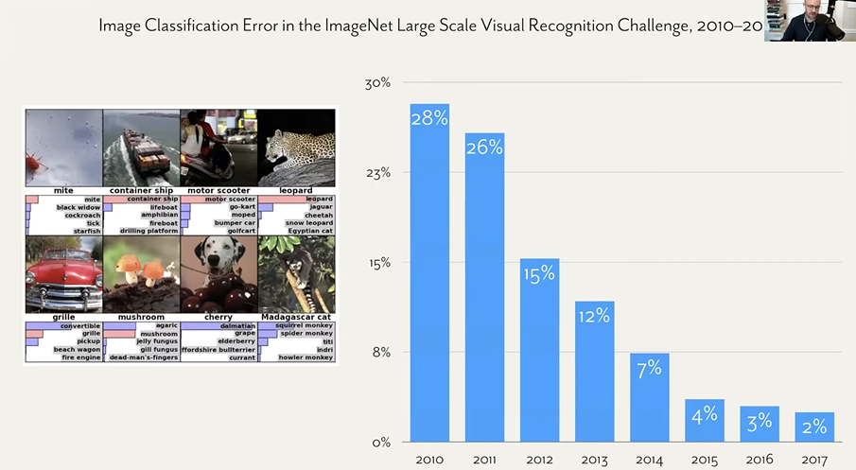

October 2012 revolution of deep learning. ImageNet. In 8 years the error rate decrease by 90% in that period of time.

today can’t even take a picture without the process. All based on what the camera thinks is seeing

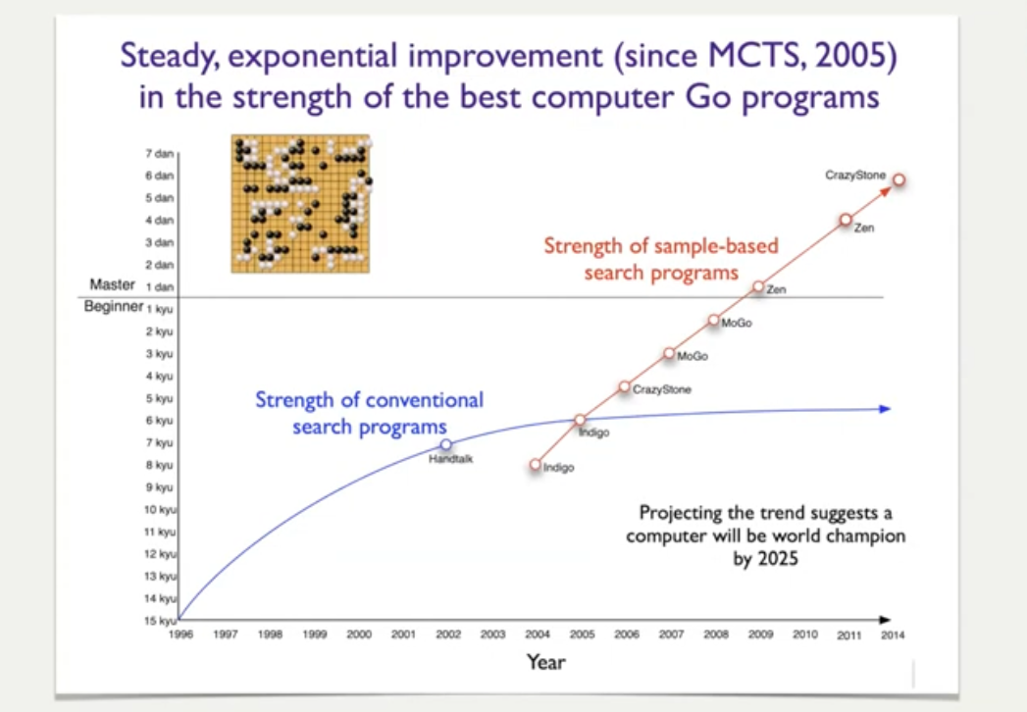

incredible boom in deep learning. Now all take for granted

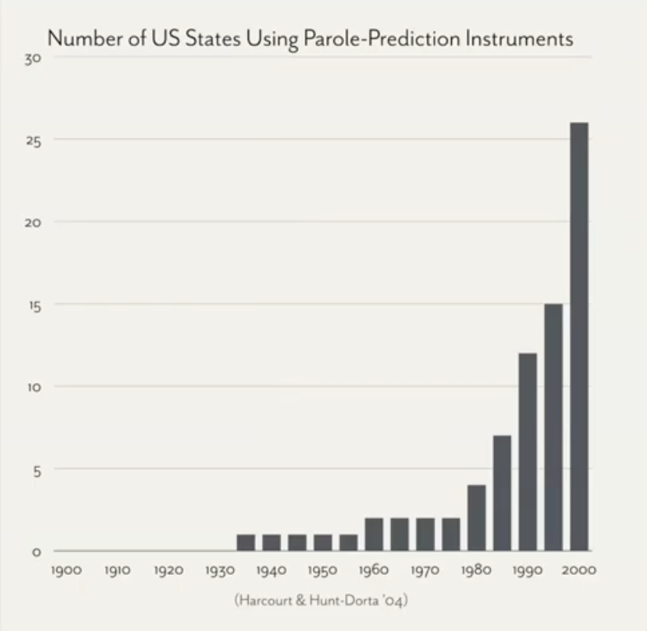

penetration of machine learning system into the actual decision-making structure of society.

Chart: states of the US that use statistical or algorithmic risk assessments scores to assist with parole (vigilanza) decision.

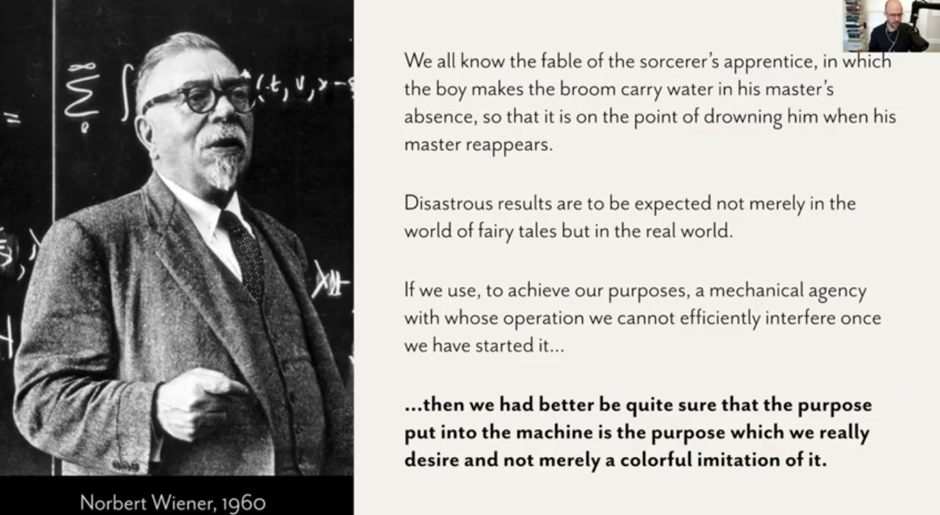

Few years ago. People started to be worried and about the ethical doubts of AI. but these concerts are hardly new. The go back to Norbert Wiener 1960.

the concern that the purpose that we put in the machine has better be the thing that we really desire ends up being the center of the fears/doubs about AI of the present days. *Are these system learning what we think they are learning? are generalizing the way we generalize? will they behave in the way that we try to incentivize them to behave?* This is **the alliment problem**

Nick Bostron + others are pointing out what we need to be worried about. Around 2015 incredible movement that gather at the insersection of those concer. Started non-prof groups (openAI, deepMind…) incredible gathering of momentum.

We have many reasons to be worried but also we have many reasons to be encouraged and proud of the progress.

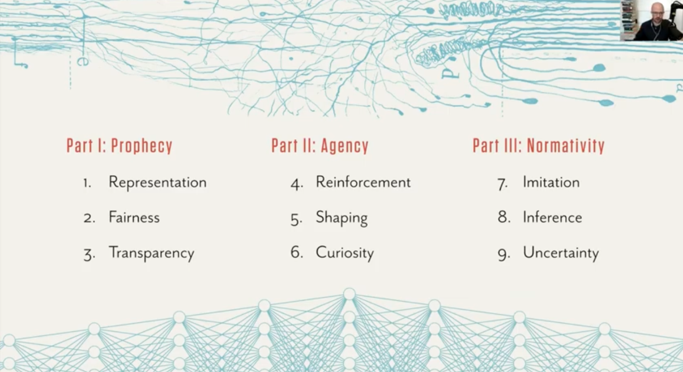

3 sections

part 1: question of bias, fairness and transparency in present days ML system (moslty supervised)

part 2: origin of reinforced learning and connections to cognitive science and neuroscience

part 3: technical AI safety. How we are trying to align sophsitcaed reinfroecd learning system with human norms and human values.

**Representation: what actually go in the training data**

Jacky Alciné. Iconic failure of deep learning.

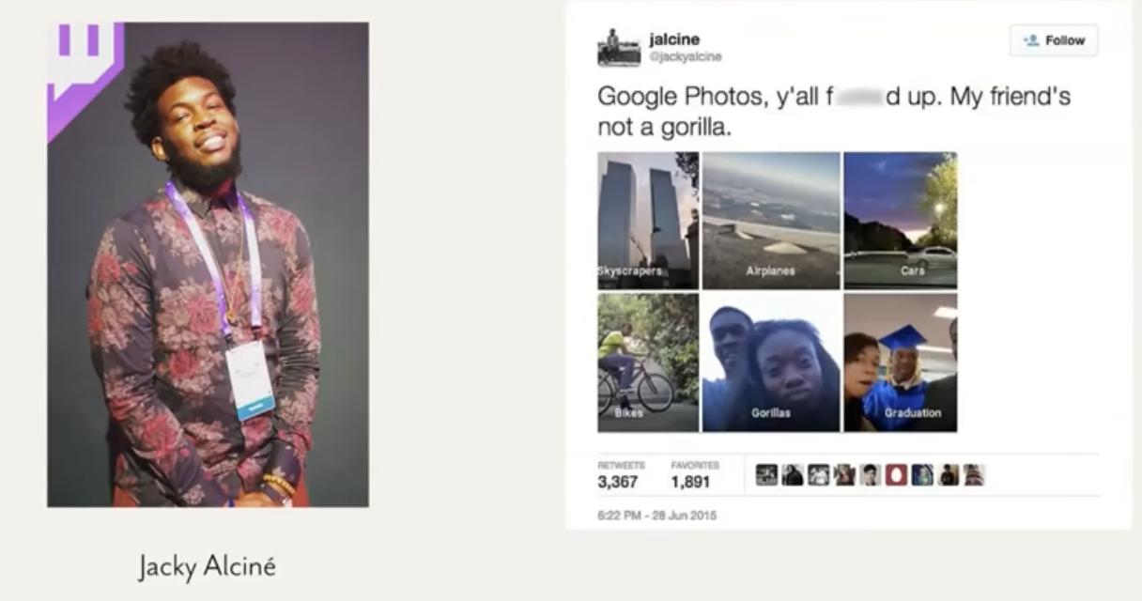

Google Photo created a photo album automatically of self pics of him and friends and they are tagged as gorillas. It triggers a movement in image recognition.

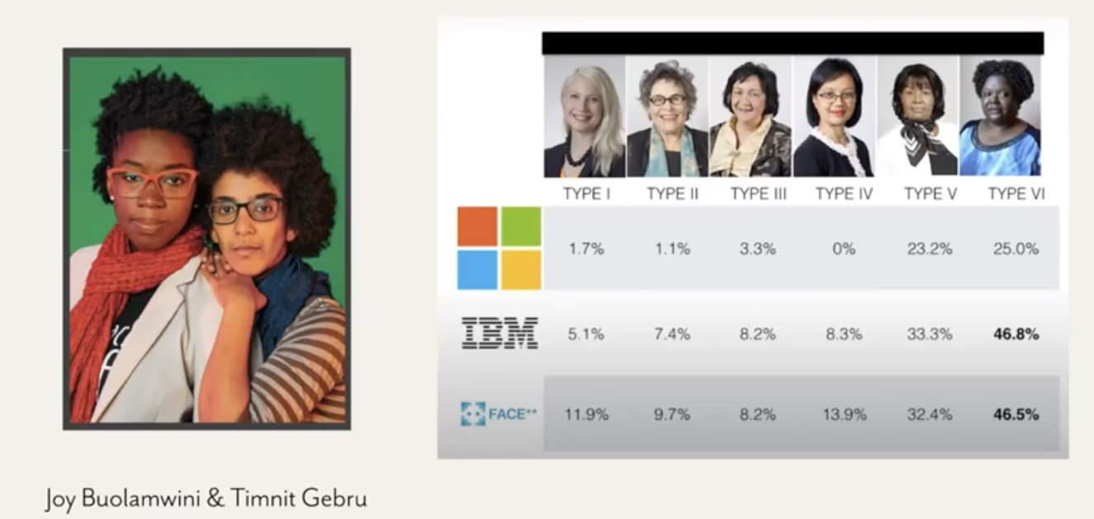

Buolawini & Gebru works about analysis of face recognition categorization. The error rates for dark skin females can be 10x then the error rates for light skinned males. ⟹ lot of rethinking of the filed of image recognition

democratic background of the label faces in the wild dataset (used end 2000 a lot) the data set 77% nale and 83% white people. Because it was compiled by photographs at the end of 2000 the most prevalent individual is George W. Bush. There are **twice as many photo of Bush in the dataset than all black woman combined**

It transform the way that researcer think about diversity.

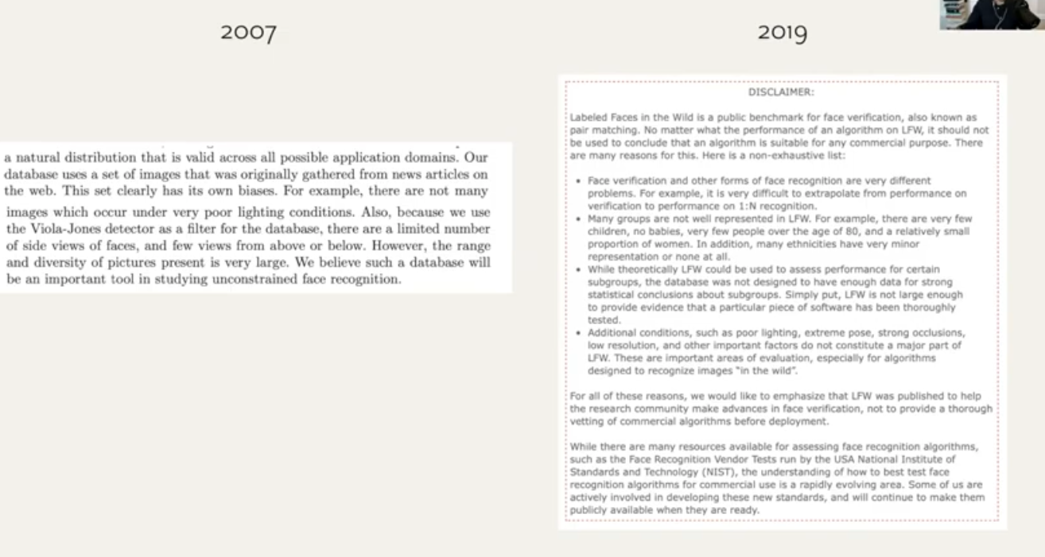

2007: label faces in wild dataset

There are some biases (they were aware) not many images under poor light condition. and limited image from side or above/below. However there is a large variety of pictures present in the dataset.

2019: label faces use disclaimer. Many groups are not very well represented (no children, no baby, few people over 80 years old…) not approprier representation for all the groups. **This indicates a shift in the whole** **field**. 13 years ago we talked about bias from the point of view of light and pose, now we think about human demographic term.

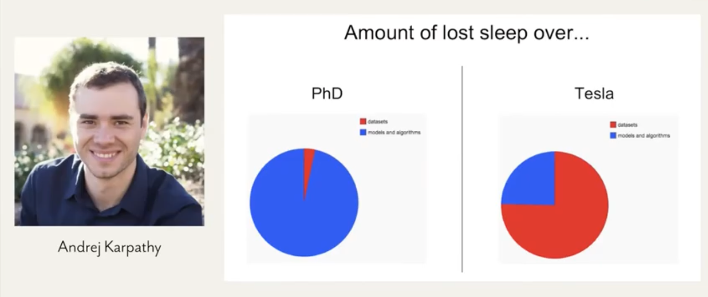

Question of physically safety also. About autonomous driving.

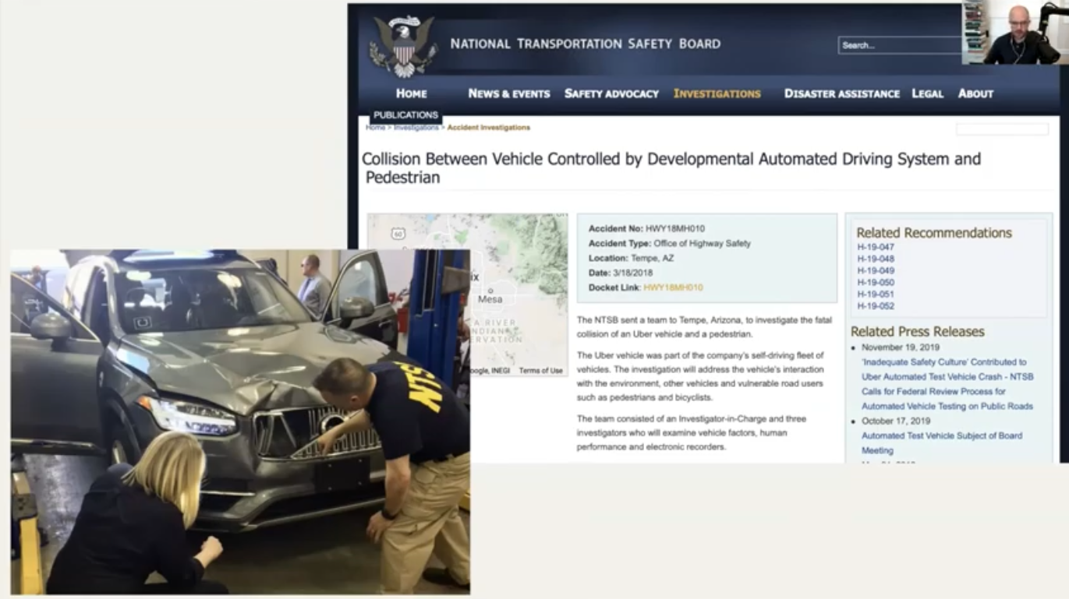

There are some accidents where autonomus vehicles kill pedestrians. 2018 pedestrian killed in arizona. One thing that came out is that the system did not have idea of jaywalkers (problem about the composition of the set). All pedestrians at the training set where crossing on the crosswalk or at a stop sign.

These isseu about whether the data maces the actual deployed environment is something that is a concern can also be a temporal issue. Team of computationa linguist that was trying to reproduce the accuracy of a language model that they were reading. The original paper was written in 2016 and they were trying to reproduce the model in 2017 but the model was training in docs delated in the web and some words started to drift. In 2018 the accuracy was even worst. **Even training a system with as much as data you can possibly givit you still have troubles because the world will change**

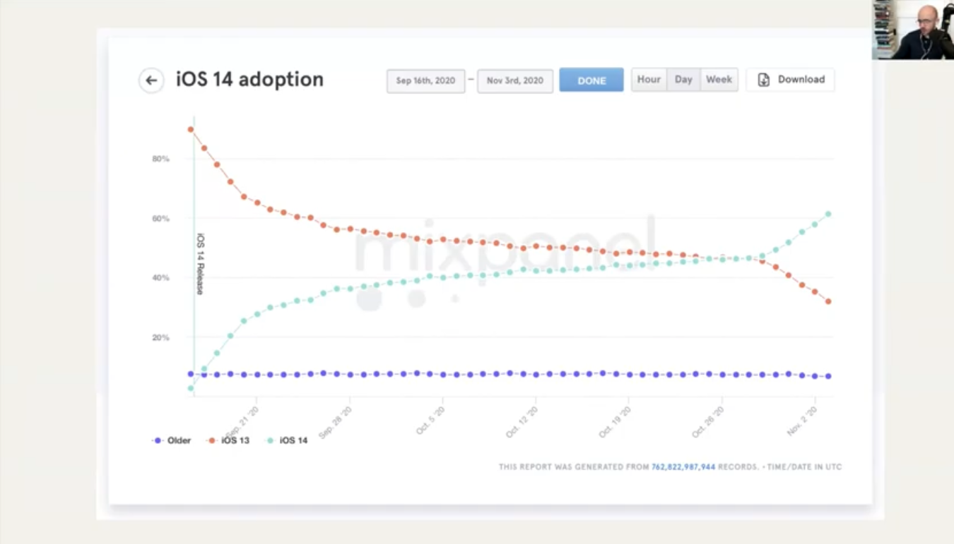

Releasing new version of the app. Including the app version as feature in the ad targeting. Target ads to people that have ios 14. But was less true. (?)

**Takes a lot of vigilancethat the training data does in fact match the environment in which a system is deployed**.

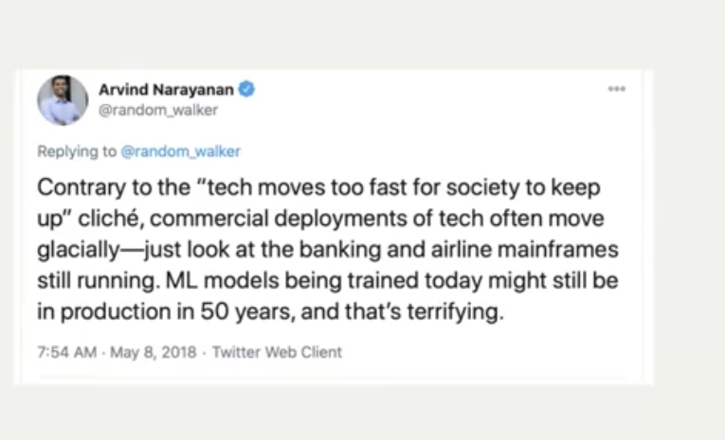

Airlines and banking system that still use cobol.

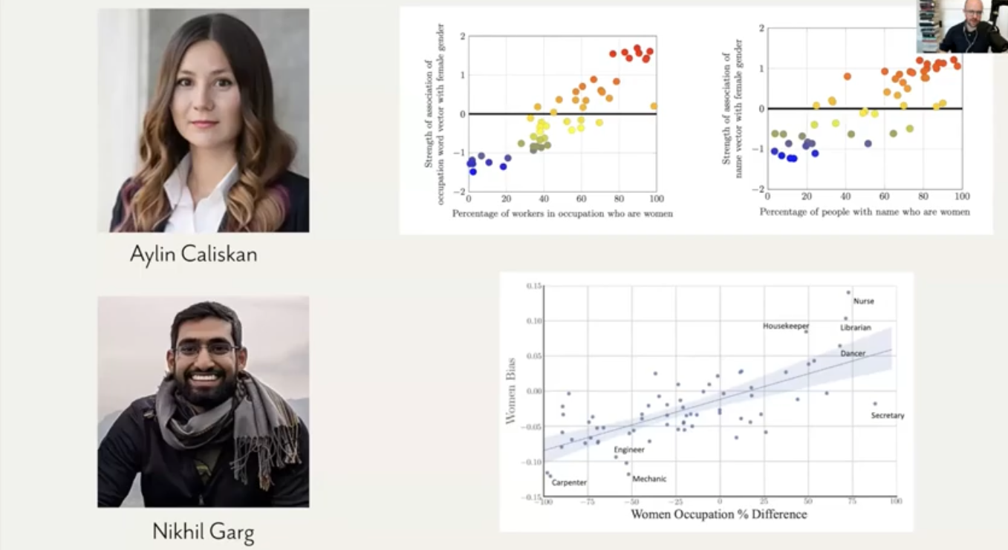

Question of representation of people in the dataset. There is a whole connection to language models and a lot of interdisciplinary work on how the interal representation of language model show us in an uncomfortable way some biases that exists in society.

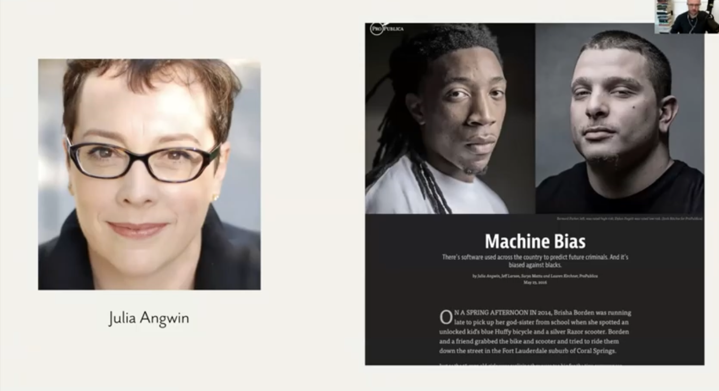

**Fairness**: lot of attention to crimial system in USA. Study show that there are unfail error rates for black and white defendeds. *How can we measure fairness in the first place? what is the proper way to operationalise some of our kind of civic and moral intuitions?*

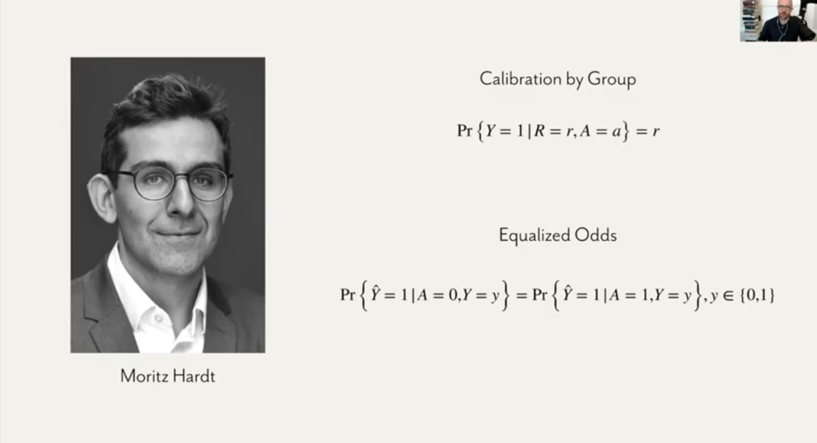

Looking to different alternative. **Calibration** if a mode rate you 8 out of 10 risk then you have the same probability of getting rearrested as someone who is rated 8 out of 10 regardless of what race/gender you are.

People start to explore new ways of articulating notation of fariness . Looking at the error rates and foro all people miss-categorized where miss-categorized in the same way or in different ways. Models shoes different outcomes. Black defaeds are 2 to 1 are more likely to be overesitamted in terms of risks and white people 2 to 1 more likely to be undersitamted in terms of risk. Question of fariness *can we build a model that follows all these criteria?*

RIPRENDRE 25.00